My Mini Christmas Cakes

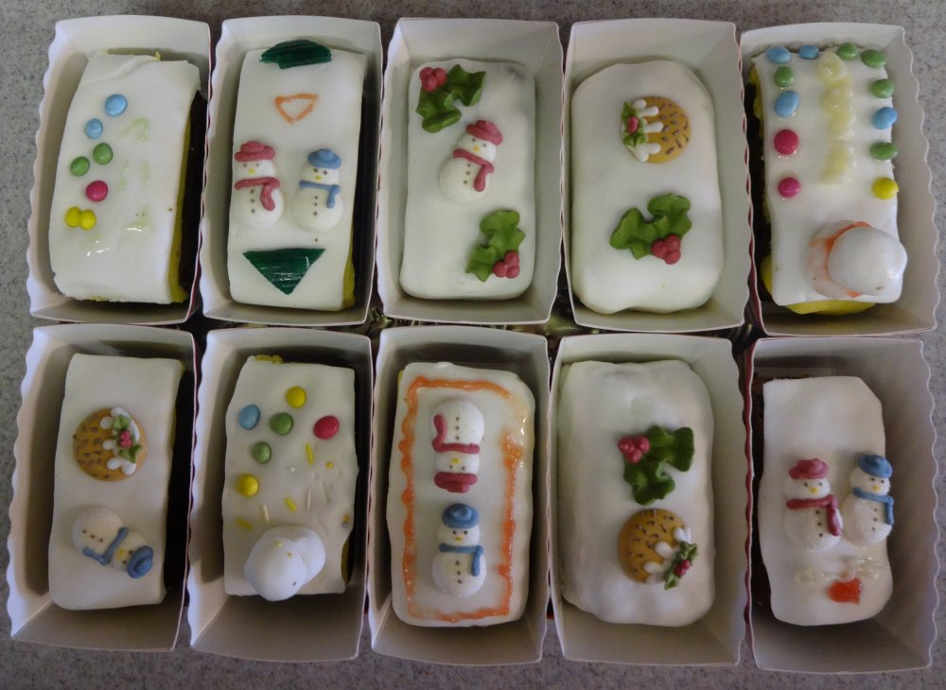

**Ingredients:**

500gm mixed dried fruit of preference – Raisins, sultanas, currants, apricots, pineapple, crystallised cherries, mixed peel, ginger. Cut up larger items such as cherries.

Grated rind and juice of ½ lemon.

30ml brandy or port

75gm unsalted butter

75gm dark muscovado sugar

15gm treacle or golden syrup

2 medium eggs

115gm plain flour

4gm baking powder

10gm mixed spice or combination to taste.

**To decorate**

Marzipan

White icing

**Method**

Heat the oven to 170oC

Put dried fruit, lemon and brandy in a bowl and leave to soak.

Beat together butter, sugar and treacle until fluffy, add the eggs and beat thoroughly, then the flour, baking powder and spice. When these are all mixed add the fruit and stir in.

Divide the mixture in to 12 mini loaf tins and smooth out. Bake for 30 – 35 minutes until deep golden colour and a skewer comes out clean. Allow to stand for 10 minutes and then place on wire rack until cool. Store in an air tight container for a week before decorating as you like.